Nanakuli students journey from farm to table
By Joleen Oshiro
Honolulu Star Advertiser

POSTED: 01:30 a.m. HST, May 06, 2015
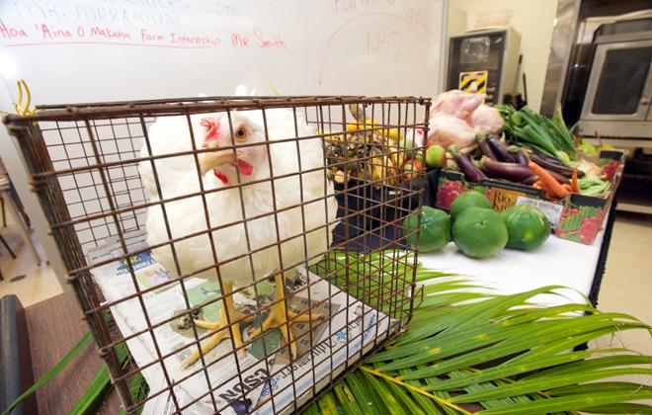

• 1 / 4
• ▶

CRAIG T. KOJIMA / CKOJIMA@STARADVERTISER.COM
Agriculture classes provided Chef Blanchard with live chickens for the meals.

The air was abuzz with excitement April 21 in Carol West's culinary classroom at Nanakuli High and Intermediate School. Students in striped aprons worked with quiet intensity as they pored over recipes, checked ovens, tended frying pans and mixed sauces. Others wore grins as they milled around the stoves, peeking into bowls and lending assistance at cutting boards.
A few yards away an array of produce was displayed — and a docile live chicken in a cage.
The scene painted a complete picture of the journey the students were an hour away from completing: a farm-to-table meal in its purest form.
Teams at each of five cooking stations were executing a final project that was to result in a balanced chicken meal. Most of the ingredients were courtesy of Myles Murakami's agriculture classes, which grew eggplant, onions, beans, mustard cabbage, bananas and more. The school's special-education students grew carrots. The ag students also raised the chickens being cooked in ovens and frying pans. Days earlier they had slaughtered the birds to ready them for the kitchen.
Was that difficult?
Sophomore Nerissa Mullen, 17, was nonplussed.
At first, "when Mr. Murakami did the demonstration, it was very scary and I was nervous," she admitted. By the time students processed their own chickens, however, they were working with confidence. Like her peers, Mullen dispelled any notion that students would have trouble reconciling both raising and slaughtering the animals.
Perhaps it helped that one classmate was an exchange student from Mozambique, where families raise chickens for food.
"My mother prefers to raise and slaughter her own chickens," said Malik Pravinchandra, 17, a junior on an eight-month exchange. Her family usually prepares chicken fried or in curry. "When you raise them at home, you can make sure they're well fed and they have their own cages. Fresh is better. Market chicken tastes dry and flavorless."
Because of her experience, Pravinchandra ended up an assistant to a culinary team, showing her skill at breaking down the chicken.
Presented on platters: Korean chicken with sauteed vegetables, island-style shoyu chicken, whole-roasted teriyaki chicken with stir-fried vegetables and mashed ulu (breadfruit), Southern-style buttermilk fried chicken with onion rings and local-style salsa, and French-roasted whole chicken.
The agriculture students were eager to taste their chicken.
"I'm pretty excited about trying the chicken we raised ourselves," said Ryan Santiago, 16, a sophomore. "My favorite is fried chicken but I like chicken in general."
Santiago stressed the importance of raising the birds with care.
"You must treat them well, respect them," he said. "You feed them, clean them up, keep their environment clean, keep them healthy."
The students received week-old chicks that they nurtured for 11 weeks, taking measurements and weights. He said a 5-1/2-pound bird about 18 inches tall is considered "a good size."
Within 30 minutes the sizeable platters of food had disappeared.
"It was fun that we got to cook what ag grew," said senior Emma Kawaiaea, 17. "I like cooking, and I know some of those kids who raised the chickens."
Santiago added, "This farm-to-table (project) is exciting — we all share, we all take care."
Though the culinary students may not have realized it, they were a privileged bunch to work with fresh chicken, as Hawaii has no commercial chicken farm. But chef Ryan Blanchard from Aulani, a Disney Resort & Spa in Ko Olina, who mentors the class, hopes the experience will inspire students to change that.
"My hope is that they are raising farmers here," he said. "When students see the culinary side of this, how it can accentuate an item, they will taste and see this is not like chicken you find in the supermarket aisles."
But Murakami's job is to give students a full picture of farming, and the lesson is a sobering one.
"I require them to write a paper about the project, and they must provide an itemized budget of what it costs to raise and feed an animal," said Murakami, who's been teaching agriculture classes at Nanakuli for 27 years. "Realistically, it's hard to do and make money."
But some of the lessons are more basic, and they have Murakami cooking for students as well.
"Everything we grow, we cook. Many of these kids today are not accustomed to eating veggies. They like fast food," he said. "I do small stuff, like eggplant with no meat. They can't believe it can have so much taste. I make tomato sandwiches. At first no one wants to eat it. But after they try it, they're looking for tomatoes in the (classroom) fridge so they can eat some later."
Both Murakami and West say that because few students are accustomed to healthful eating, it's important to teach them to cook their own food and to consider nutrition.
Another priority is teaching them to create a dish out of what's available in their pantries. Since December, West's second-year students have been cooking from "mystery bags" that contain a starch and some vegetables. "Anybody can take the absolute best ingredients and make a meal," she said. "Not everybody can take healthy ingredients and make something everybody wants to eat."
As for the career aspect of culinary training, West understands the challenges firsthand; in another life, she worked as a chef. Since then she's been converting home-economics classrooms into certified kitchens. She is in her sixth year at Nanakuli. She worked previously at Hilo and Honokaa high schools.
With the presence of Aulani, "suddenly our kids have all kinds of opportunities," West said. "We've got to get them ready."
She addresses part of that readiness via a club that comprises about 10 students passionate about cooking. They visit West's classroom during their free time to pick her brain and experiment with recipes. The club sells baked Spam musubi and pizza topped with an array of vegetables. With proceeds, West takes members to fine restaurants such as Japengo and Top of Waikiki, where they can order whatever they want to try. Top of Waikiki even allowed the students to tour the kitchen.
"If you don't expose them to that stuff, how are they supposed to cook it?" West said.
The lessons aren't lost on Bernadette Brasher-LaRue, who's in her second year of culinary class and her first year in the club.
"I like to cook. I think it's a good way to make money and a good way to make people happy," said the 15-year-old sophomore.
Brasher-LaRue said her mother taught her to cook at a young age, and she regularly jumps in to cook dinner at home. Most dishes are fast and easy, she says, like meatloaf and pasta.
But the teen has her eye on more challenging fare.
"I'm hoping to learn about culinary arts and different kinds of cuisine," she said. "I want to learn how to make refined, gourmet food."

